YOUR TITLE GOES HERE: UNIVERSITY OF FLORIDA
TEMPLATE FOR PREPARING THESES AND DISSERTATIONS

By

YOUR NAME GOES HERE IN ALL CAPITAL LETTERS

A DISSERTATION PRESENTED TO THE GRADUATE SCHOOL
OF THE UNIVERSITY OF FLORIDA IN PARTIAL FULFILLMENT
OF THE REQUIREMENTS FOR THE DEGREE OF
DOCTOR OF PHILOSOPHY

UNIVERSITY OF FLORIDA

YYYY

© YYYY Your Name Goes Here in Title Case

Your dedication is typed here. It should begin with the word “To.”
(To my Mom is a typical dedication) If your dedication is longer than a single line it should be single-spaced, and centered vertically and horizontally

ACKNOWLEDGMENTS
Acknowledgments must be written in complete sentences. Do not use direct address. For example, instead of Thanks, Mom and Dad!, you should say I thank my parents. The heading “ACKNOWLEDGMENTS” uses the 002 CHAPTER TITLE style.. The paragraphs in this section should use the style called 006 Body Text.

TABLE OF CONTENTS

page
ACKNOWLEDGMENTS 4
LIST OF TABLES 7
LIST OF FIGURES 8
LIST OF OBJECTS 9
LIST OF ABBREVIATIONS 10
ABSTRACT 11
CHAPTER
1 TITLE OF CHAPTER ONE 12
First Level Subheading 12
First Level Subheading 13
Second Level Subheading 14
Third level subheading 14
Third level subheading 15
Second Level Subheading 15
2 TITLE OF CHAPTER TWO 21
First Level Subheading 21
First Level Subheading 22
Second Level Subheading 23
Third level subheading 23
Third level subheading 24
Second Level Subheading 24
3 TITLE OF CHAPTER THREE 30
First Level Subheading 30
First Level Subheading 31
Second Level Subheading 32
Third level subheading 32
Third level subheading 33
Second Level Subheading 33
APPENDIX
A TITLE PAGE SAMPLE 39
B COPYRIGHT PAGE SAMPLE 40
C TABLE OF CONTENTS SAMPLES 41
Sample Table of Contents for Numbered Chapters 41
Sample Table of Contents for Numbered Chapters and Subdivisions 42
Sample Table of Contents for Theses and Dissertations without Chapter Numbers 43
Sample Table of Contents for Creative Writing 44
NOTE: This page is an example of how to request permission to use copyrighted material and is not to be included in the Thesis or Dissertation. If you use material from another author you must submit this completed form to the Graduate Editorial Office prior to receiving Final Clearance. 45
Permission to Reproduce Copyrighted Material 45
LIST OF REFERENCES 46
BIOGRAPHICAL SKETCH 48

LIST OF TABLES
Table page

1-1 Table captions go at the top of the table but should not be part of the table itself. 16
1-2 The best practice is to place Tables and Figures at the end of the Chapter. 17
1-3 Tables that can’t fit on a single page must be split across two of more pages. 19
2-1 Table captions go at the top of the table but should not be part of the table itself. 25
2-2 The best practice is to place Tables and Figures at the end of the Chapter. 26
2-3 Tables that can’t fit on a single page must be split across two of more pages. 28
3-1 Table captions go at the top of the table but should not be part of the table itself. 34
3-2 The best practice is to place Tables and Figures at the end of the Chapter. 35
3-3 Tables that can’t fit on a single page must be split across two of more pages. 37

LIST OF FIGURES
Figure page

1-1 Figure numbers take the form of Chapter number-Figure number and the figure caption uses the style 014 Figure Caption. 16
1-2 Multi-part figures should be clearly labeled, without punctuation. And have a description of the whole figure as the first part of the caption. 17
1-3 There should be a space between a figure and the figure caption, while the Table caption sits right on top of the Table. 20
2-1 Figure numbers take the form of Chapter number-Figure number and the figure caption uses the style 014 Figure Caption. 25
2-2 Multi-part figures should be clearly labeled, without punctuation. And have a description of the whole figure as the first part of the caption. 26
2-3 There should be a space between a figure and the figure caption, while the Table caption sits right on top of the Table. 29
3-1 Figure numbers take the form of Chapter number-Figure number and the figure caption uses the style 014 Figure Caption. 34
3-2 Multi-part figures should be clearly labeled, without punctuation. And have a description of the whole figure as the first part of the caption. 35
3-3 There should be a space between a figure and the figure caption, while the Table caption sits right on top of the Table. 38

LIST OF OBJECTS
Object page

1-1 An Audio, Video, or large chunk of data you wish to make available to the reader. Tell the reader the type and size of the file 15
1-2 Objects are numbered the same way that Tables and Figures are numbered. You would make these captions the hyperlinks to your Object Files. 15
2-1 An Audio, Video, or large chunk of data you wish to make available to the reader. Tell the reader the type and size of the file 24
2-2 Objects are numbered the same way that Tables and Figures are numbered. You would make these captions the hyperlinks to your Object Files. 24
3-1 An Audio, Video, or large chunk of data you wish to make available to the reader. Tell the reader the type and size of the file 33
3-2 Objects are numbered the same way that Tables and Figures are numbered. You would make these captions the hyperlinks to your Object Files. 33

LIST OF ABBREVIATIONS
Word to be defined | Write the definition here. Do not put any hard carriage returns in the definition and it will wrap like this automatically. When you are done with the definition, press the “Tab” key once and you will advance to the next cell
Next word | And the list continues. This is actually a table with no boarders and gives the effect of two separate columns so the definitions can wrap in their column and the words (or phrases) to be defined can wrap in their column as well.
Another word | Remember to use a tab between the abbreviations and the definitions. A Tab will also advance you to the next line of the Table and will generate a new line if you hit “Tab” in the last cell of the table. Use the “Borders” button in the “Paragraph” section of the “Home” tab to show the cells of the table available, just remember to turn them off when you’re done.

Abstract of Dissertation Presented to the Graduate School
of the University of Florida in Partial Fulfillment of the
Requirements for the Degree of Doctor of Philosophy

TITLE OF THE WORK, CENTERED, SINGLE-SPACED,
IN ALL CAPITAL LETTERS, EXACTLY AS ON TITLE PAGE
By
Your Name as on the Title Page, but in Title Case

Month and year of graduation

Chair: Name (Do not put Dr. before the name, and do not put degrees after it)
Cochair: Name (if any, otherwise delete this line)
Major: See your Editorial Document Management record for your exact major

Dissertation abstracts must be 350 words or less. The electronic and pdf versions must be the same (except for the spelling out of Greek letters and symbols in the electronic version) and note that the electronic version will be truncated at 350 words. Thesis abstracts should be 250 words or less.
The { TC ABSTRACT } in the first paragraph is a Table of Contents field that allows us to bring the word “Abstract” into the TOC without assigning it a specific style. It can only be seen if the show/hide toggle is set to “show.” Removing this will cause your Table of Contents to be improperly formatted.

CHAPTER 1

TITLE OF CHAPTER ONE
There does not have to be a heading at the beginning of each Chapter– which is, by definition, the introduction to the chapter.* Any Chapter Title should not be used as a subheading in any other Chapter. The organization and order of your Chapters is up to you and your Committee. There are some basic requirements. If you are writing a “Three Paper Dissertation,” there must be a separate introductory Chapter and a separate conclusion Chapter. There should be only one Abstract for the entire document, and one list of References as well. Most of the time a review of the current literature on the subject is included, again, whether it is a stand alone chapter or a section of the introduction is between you and your Committee.
Many Dissertations contain mathematical equations or formulae. These can be troublesum if you try to place them within the text. We find that placing an equation within a one line table often solves the problem:
$${\left(x+a\right)}^{n}=\sum_{k=0}^{n}{\left({n \atop k}\right)x^{k}a^{n-k}}$$ | (1-1)
Turning off the border makes it appear as if it was simply inserted in the text. Note the equation label is aligned with the right hand margin and is keyed to the chapter just like Tables and Figures but the word “equation” is not used in the label. Use 007 Body Text No Indent to continue in the same paragraph after the equation, and 006 Body Text to start a new subject.

First Level Subheading
First Level Subheadings are in Title Case (every principal word is capitalized, except, prepositions, conjunctions, and articles. 006 Body Text comprises the majority of the text in the document. Each of the styles are presented in every chapter of the template. You only need to keep one chapter in your document until the document is fully formatted. Once you are finished with the formatting you can delete the Template Text. If, for some reason, you find you need a style not included in your finished document. All you have to do is copy one chapter from the template, paste it to the end of your file and the missing style will be available again.
008 Block Text-Block Quote. Any quote that is more than three lines long (approximately 40 words) should be set as a block quote. Block quotes are single-spaced and indented one-half inch on both the left and right margins. No quotes are needed in a block quote, unless the person your are quoting is quoting someone else.
More than one paragraph can be used in a block quote. They are indicated by a line space that is built into the style. Just press return once at the end of the paragraph or quote to move on to another subject.
007 Body Text-No Indent. (used to continue a paragraph after a quote or list) Nulla vel volutpat enim. Curabitur molestie ut enim non bibendum. Praesent id justo posuere, vestibulum lectus tempor, tempus libero. Nunc dictum, arcu sodales fringilla ornare,

First Level Subheading
006 Body Text. neque dui pulvinar nulla, et consequat velit arcu quis eros. Quisque massa diam, tempor eget arcu egestas, consectetur sollicitudin neque.
- 009 Short List - Bullets
- Used when no item in the list is longer
- Than a single line.

A short list is any list where no item is longer than a single line. The list is single-spaced with a space before and after the list. 006 Body Text provides the space before, but you must provide the space after. Press return to move to the next line and “Clear All” to make that new line empty space. 010 Short List – Numbers works the same way but enumerates the list instead of using bullets. The problem with the 010 Short List Numbers is that if you have a second numbered list, Word will continue the numbering from the previous list. If you attempt to make the list start over at 1, the formatting of the list will need to be manually adjusted.

Second Level Subheading
Second Level headings are also in Title Case, but are left-aligned instead of centered. O11 Long List – Bullets style is used if any of the lines in the list wrap to a second line. In that case the items are single-spaced but there is a space between each item.
- Proin vehicula diam non
- faucibus imperdiet. Fusce mattis
- tortor et velit viverra, sit amet blandit ipsum finibus.
- Vivamus vehicula sed elit
- vitae finibus. Sed egestas nunc in mi pretium, in rhoncus tellus facilisis. Class aptent taciti sociosqu ad litora torquent per conubia nostra,
- per inceptos himenaeos.
- Phasellus fermentum
With a long list the space at the end of the list is built in and does not have to be added. The biggest problem with 012 Long List – Numbers (or numbered lists in general) is that the second time you use the style it will continue the numbers from the first list. When you change it to re-start at 1, the formatting will revert to the default numbered list format. So you will have to re-set the hanging indent to 0.5” and set the left indent back to 0.

Third level subheading
Third level headings are left-aligned, but are in sentence case (The first word and any proper nouns are capitalized). 016 Transcribed dialog is used to quote participants in a study:
Name1: Dialog test presented in the dialog
Name2: Response to the first speaker. It’s not necessary to have two speakers, you’re just presenting comments from a study for the reader’s benefit.
007 Body Text – No Indent would be used to continue in the same train of thought, where regular 006 Body Text would start a new paragraph.

Third level subheading
Large amounts of data, audio, or video files can be stored in the UF Library System in the Institutional Repository Digital Collections. These files are called “Objects” and are accessed via a URL that is provided after you upload the file (Contact the Library for instructions on uploading). In your document, where you are discussing the Object File you should place the link to the file as an 015 Object Caption.
Object 1-1. An Audio, Video, or large chunk of data you wish to make available to the reader. Tell the reader the type and size of the file
Object 1-2. Objects are numbered the same way that Tables and Figures are numbered. You would make these captions the hyperlinks to your Object Files.
If you don’t have any objects (and most will not) feel free to delete the List of Objects page.

Second Level Subheading
There must be a second, second level subheading in this section to correctly follow the rules of outlining. Any section that is divided must be divided by two or more sections
Paragraph headings. The only exception is a paragraph heading, which is still formatted as 006 Body Text. It appears at the beginning of the sentence, ends with a period or colon, is in sentence case, and in bold. It can appear at any level and does not have to be paired as do the First, Second and Third level subheadings.

Table 1-1. Table captions go at the top of the table but should not be part of the table itself. The table numbers are keyed to the chapter (chapter number-table number) and the captions have the style 013 Table Caption. The table number should hang outside of the table caption
 | This heading covers 2 & 3 |  | This heading covers 4 & 5
Heading1 | Heading 2 | Heading 3 | Heading 4ª | Heading 5
Row heading | Data | Data | 0.002 | Data
Row subheading | Data | Data | 43.4 | Data
Subheading | Data | Data | 100.456 | Data
Row heading | Data | Data | 2.5 | Data
Notes go below the table but are not part of the table. The best practice is to make them in paragraph style, not as a list. ª Numerical data should be aligned on a decimal tab. Select the column and place the tab using the Ruler. Notes are usually made in 10 pt. type. Tables should not have ANY vertical lines and only the minimum horizontal lines. Most tables are best when they are the full width of the text (6.5 in.)

Figure 1-1. Figure numbers take the form of Chapter number-Figure number and the figure caption uses the style 014 Figure Caption. The caption is left-aligned with a hanging indent and goes at the bottom of the figure. There should be one line of space between the figure and the caption.

Table 1-2. The best practice is to place Tables and Figures at the end of the Chapter. Once the paragraph text has ended, the requirement to make the pages full ends as well giving more freedom in your spacing.
Heading1 | Heading 2 | Heading 3
Data | Data | Data
Data | Data | Data
Data | Data | Data
Data | Data | Data
Data | Data | Data
Data | Data | Data
Data | Data | Data
Data | Data | Data
Even small tables generally look best when set to the full width of the text (6.5”)

A 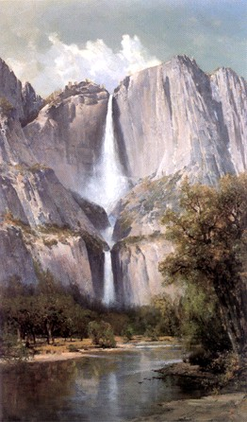 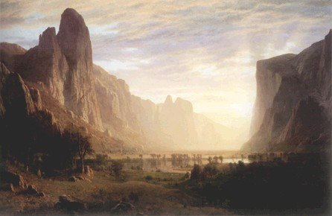 B

Figure 1-2. Multi-part figures should be clearly labeled, without punctuation. And have a description of the whole figure as the first part of the caption. Then you can describe A) the waterfall, B) the canyon, C) the Montana poster and D) the waterfall poster. These sub-captions can be removed in the actual List of Figures to make it much cleaner and compact. If the figure continues to a second page, the entire caption should appear on the first page of the figure and the following pages should be labeled as “Figure X-W. Continued” – do not apply the Figure Caption Style to the continued notation and it should not appear in the List of Figures.
C 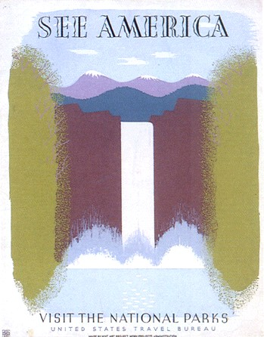 D

Figure 1-2. Continued

Table 1-3. Tables that can’t fit on a single page must be split across two of more pages. When this happens, you actually split the table into a new table starting on the next page without a table caption – just the table number and the word “Continued” at the top of the Table. You also have to repeat the headings at the top of the second (and subsequent) page(s). Table text can be reduced from 12 pts. to 10 pts. to fit more data on the page if desired.
Category | Heading 1 | Heading 2 | Heading 3 | Heading 4
Row heading | Data | Data | Data | Data
Row heading | Data | Data | Data | Data
Row heading | Data | Data | Data | Data
Row heading | Data | Data | Data | Data
Row heading | Data | Data | Data | Data
Row heading | Data | Data | Data | Data
Row heading | Data | Data | Data | Data
Row heading | Data | Data | Data | Data
Row heading | Data | Data | Data | Data
Row heading | Data | Data | Data | Data
Row heading | Data | Data | Data | Data
Row heading | Data | Data | Data | Data
Row heading | Data | Data | Data | Data
Row heading | Data | Data | Data | Data
Row heading | Data | Data | Data | Data
Row heading | Data | Data | Data | Data
Row heading | Data | Data | Data | Data
Row heading | Data | Data | Data | Data
Row heading | Data | Data | Data | Data
Row heading | Data | Data | Data | Data
Row heading | Data | Data | Data | Data
Row heading | Data | Data | Data | Data
Row heading | Data | Data | Data | Data
Row heading | Data | Data | Data | Data
Row heading | Data | Data | Data | Data
Row heading | Data | Data | Data | Data
Row heading | Data | Data | Data | Data
Row heading | Data | Data | Data | Data
Row heading | Data | Data | Data | Data
Row heading | Data | Data | Data | Data
Row heading | Data | Data | Data | Data
Row heading | Data | Data | Data | Data
Row heading | Data | Data | Data | Data
Row heading | Data | Data | Data | Data
Row heading | Data | Data | Data | Data
Row heading | Data | Data | Data | Data
Row heading | Data | Data | Data | Data
Row heading | Data | Data | Data | Data

Table 1-3. Continued
Category | Heading 1 | Heading 2 | Heading 3 | Heading 4
Row heading | Data | Data | Data | Data
Row heading | Data | Data | Data | Data
Row heading | Data | Data | Data | Data
Row heading | Data | Data | Data | Data
Row heading | Data | Data | Data | Data
Row heading | Data | Data | Data | Data
Row heading | Data | Data | Data | Data
Row heading | Data | Data | Data | Data
Row heading | Data | Data | Data | Data
Row heading | Data | Data | Data | Data

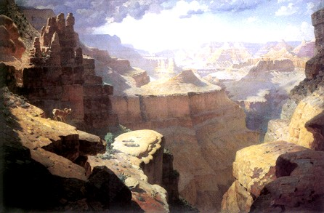

Figure 1-3. There should be a space between a figure and the figure caption, while the Table caption sits right on top of the Table. If the image has white space included at the bottom that can be used to be the needed space but make sure there is a return between the figure and the caption to keep the figure from becoming part of the List of Figures/Tables. My preference is for figures to be centered, but left aligned is OK – just be consistent.

CHAPTER 2

TITLE OF CHAPTER TWO
There does not have to be a heading at the beginning of each Chapter– which is, by definition, the introduction to the chapter. Any Chapter Title should not be used as a subheading in any other Chapter. The organization and order of your Chapters is up to you and your Committee. There are some basic requirements. If you are writing a “Three Paper Dissertation,” there must be a separate introductory Chapter and a separate conclusion Chapter. There should be only one Abstract for the entire document, and one list of References as well. Most of the time a review of the current literature on the subject is included, again, whether it is a stand alone chapter or a section of the introduction is between you and your Committee.
Many Dissertations contain mathematical equations or formulae. These can be troublesum if you try to place them within the text. We find that placing an equation within a one line table often solves the problem:
$${\left(x+a\right)}^{n}=\sum_{k=0}^{n}{\left({n \atop k}\right)x^{k}a^{n-k}}$$ | (2-1)
Turning off the border makes it appear as if it was simply inserted in the text. Note the equation label is aligned with the right hand margin and is keyed to the chapter just like Tables and Figures but the word “equation” is not used in the label. Use 007 Body Text No Indent to continue in the same paragraph after the equation, and 006 Body Text to start a new subject.

First Level Subheading
First Level Subheadings are in Title Case (every principal word is capitalized, except, prepositions, conjunctions, and articles.* 006 Body Text comprises the majority of the text in the document. Each of the styles are presented in every chapter of the template. You only need to keep one chapter in your document until the document is fully formatted. Once you are finished with the formatting you can delete the Template Text. If, for some reason, you find you need a style not included in your finished document. All you have to do is copy one chapter from the template, paste it to the end of your file and the missing style will be available again.
008 Block Text-Block Quote. Any quote that is more than three lines long (approximately 40 words) should be set as a block quote. Block quotes are single-spaced and indented one-half inch on both the left and right margins. No quotes are needed in a block quote, unless the person your are quoting is quoting someone else.
More than one paragraph can be used in a block quote. They are indicated by a line space that is built into the style. Just press return once at the end of the paragraph or quote to move on to another subject.
007 Body Text-No Indent. (used to continue a paragraph after a quote or list) Nulla vel volutpat enim. Curabitur molestie ut enim non bibendum. Praesent id justo posuere, vestibulum lectus tempor, tempus libero. Nunc dictum, arcu sodales fringilla ornare,

First Level Subheading
006 Body Text. neque dui pulvinar nulla, et consequat velit arcu quis eros. Quisque massa diam, tempor eget arcu egestas, consectetur sollicitudin neque.
- 009 Short List - Bullets
- Used when no item in the list is longer
- Than a single line.

A short list is any list where no item is longer than a single line. The list is single-spaced with a space before and after the list. 006 Body Text provides the space before, but you must provide the space after. Press return to move to the next line and “Clear All” to make that new line empty space. 010 Short List – Numbers works the same way but enumerates the list instead of using bullets. The problem with the 010 Short List Numbers is that if you have a second numbered list, Word will continue the numbering from the previous list. If you attempt to make the list start over at 1, the formatting of the list will need to be manually adjusted.

Second Level Subheading
Second Level headings are also in Title Case, but are left-aligned instead of centered. O11 Long List – Bullets style is used if any of the lines in the list wrap to a second line. In that case the items are single-spaced but there is a space between each item.
- Proin vehicula diam non
- faucibus imperdiet. Fusce mattis
- tortor et velit viverra, sit amet blandit ipsum finibus.
- Vivamus vehicula sed elit
- vitae finibus. Sed egestas nunc in mi pretium, in rhoncus tellus facilisis. Class aptent taciti sociosqu ad litora torquent per conubia nostra,
- per inceptos himenaeos.
- Phasellus fermentum
With a long list the space at the end of the list is built in and does not have to be added. The biggest problem with 012 Long List – Numbers (or numbered lists in general) is that the second time you use the style it will continue the numbers from the first list. When you change it to re-start at 1, the formatting will revert to the default numbered list format. So you will have to re-set the hanging indent to 0.5” and set the left indent back to 0.

Third level subheading
Third level headings are left-aligned, but are in sentence case (The first word and any proper nouns are capitalized). 016 Transcribed dialog is used to quote participants in a study:
Name1: Dialog test presented in the dialog
Name2: Response to the first speaker. It’s not necessary to have two speakers, you’re just presenting comments from a study for the reader’s benefit.
007 Body Text – No Indent would be used to continue in the same train of thought, where regular 006 Body Text would start a new paragraph.

Third level subheading
Large amounts of data, audio, or video files can be stored in the UF Library System in the Institutional Repository Digital Collections. These files are called “Objects” and are accessed via a URL that is provided after you upload the file (Contact the Library for instructions on uploading). In your document, where you are discussing the Object File you should place the link to the file as an 015 Object Caption.
Object 2-1. An Audio, Video, or large chunk of data you wish to make available to the reader. Tell the reader the type and size of the file
Object 2-2. Objects are numbered the same way that Tables and Figures are numbered. You would make these captions the hyperlinks to your Object Files.
If you don’t have any objects (and most will not) feel free to delete the List of Objects page.

Second Level Subheading
There must be a second, second level subheading in this section to correctly follow the rules of outlining. Any section that is divided must be divided by two or more sections
Paragraph headings. The only exception is a paragraph heading, which is still formatted as 006 Body Text. It appears at the beginning of the sentence, ends with a period or colon, is in sentence case, and in bold. It can appear at any level and does not have to be paired as do the First, Second and Third level subheadings.

Table 2-1. Table captions go at the top of the table but should not be part of the table itself. The table numbers are keyed to the chapter (chapter number-table number) and the captions have the style 013 Table Caption. The table number should hang outside of the table caption
 | This heading covers 2 & 3 |  | This heading covers 4 & 5
Heading1 | Heading 2 | Heading 3 | Heading 4ª | Heading 5
Row heading | Data | Data | 0.002 | Data
Row subheading | Data | Data | 43.4 | Data
Subheading | Data | Data | 100.456 | Data
Row heading | Data | Data | 2.5 | Data
Notes go below the table but are not part of the table. The best practice is to make them in paragraph style, not as a list. ª Numerical data should be aligned on a decimal tab. Select the column and place the tab using the Ruler. Notes are usually made in 10 pt. type. Tables should not have ANY vertical lines and only the minimum horizontal lines. Most tables are best when they are the full width of the text (6.5 in.)

Figure 2-1. Figure numbers take the form of Chapter number-Figure number and the figure caption uses the style 014 Figure Caption. The caption is left-aligned with a hanging indent and goes at the bottom of the figure. There should be one line of space between the figure and the caption.

Table 2-2. The best practice is to place Tables and Figures at the end of the Chapter. Once the paragraph text has ended, the requirement to make the pages full ends as well giving more freedom in your spacing.
Heading1 | Heading 2 | Heading 3
Data | Data | Data
Data | Data | Data
Data | Data | Data
Data | Data | Data
Data | Data | Data
Data | Data | Data
Data | Data | Data
Data | Data | Data
Even small tables generally look best when set to the full width of the text (6.5”)

A B

Figure 2-2. Multi-part figures should be clearly labeled, without punctuation. And have a description of the whole figure as the first part of the caption. Then you can describe A) the waterfall, B) the canyon, C) the Montana poster and D) the waterfall poster. These sub-captions can be removed in the actual List of Figures to make it much cleaner and compact. If the figure continues to a second page, the entire caption should appear on the first page of the figure and the following pages should be labeled as “Figure X-W. Continued” – do not apply the Figure Caption Style to the continued notation and it should not appear in the List of Figures.
C D

Figure 2-2. Continued

Table 2-3. Tables that can’t fit on a single page must be split across two of more pages. When this happens, you actually split the table into a new table starting on the next page without a table caption – just the table number and the word “Continued” at the top of the Table. You also have to repeat the headings at the top of the second (and subsequent) page(s). Table text can be reduced from 12 pts. to 10 pts. to fit more data on the page if desired.
Category | Heading 1 | Heading 2 | Heading 3 | Heading 4
Row heading | Data | Data | Data | Data
Row heading | Data | Data | Data | Data
Row heading | Data | Data | Data | Data
Row heading | Data | Data | Data | Data
Row heading | Data | Data | Data | Data
Row heading | Data | Data | Data | Data
Row heading | Data | Data | Data | Data
Row heading | Data | Data | Data | Data
Row heading | Data | Data | Data | Data
Row heading | Data | Data | Data | Data
Row heading | Data | Data | Data | Data
Row heading | Data | Data | Data | Data
Row heading | Data | Data | Data | Data
Row heading | Data | Data | Data | Data
Row heading | Data | Data | Data | Data
Row heading | Data | Data | Data | Data
Row heading | Data | Data | Data | Data
Row heading | Data | Data | Data | Data
Row heading | Data | Data | Data | Data
Row heading | Data | Data | Data | Data
Row heading | Data | Data | Data | Data
Row heading | Data | Data | Data | Data
Row heading | Data | Data | Data | Data
Row heading | Data | Data | Data | Data
Row heading | Data | Data | Data | Data
Row heading | Data | Data | Data | Data
Row heading | Data | Data | Data | Data
Row heading | Data | Data | Data | Data
Row heading | Data | Data | Data | Data
Row heading | Data | Data | Data | Data
Row heading | Data | Data | Data | Data
Row heading | Data | Data | Data | Data
Row heading | Data | Data | Data | Data
Row heading | Data | Data | Data | Data
Row heading | Data | Data | Data | Data
Row heading | Data | Data | Data | Data
Row heading | Data | Data | Data | Data
Row heading | Data | Data | Data | Data

Table 2-3. Continued
Category | Heading 1 | Heading 2 | Heading 3 | Heading 4
Row heading | Data | Data | Data | Data
Row heading | Data | Data | Data | Data
Row heading | Data | Data | Data | Data
Row heading | Data | Data | Data | Data
Row heading | Data | Data | Data | Data
Row heading | Data | Data | Data | Data
Row heading | Data | Data | Data | Data
Row heading | Data | Data | Data | Data
Row heading | Data | Data | Data | Data
Row heading | Data | Data | Data | Data

Figure 2-3. There should be a space between a figure and the figure caption, while the Table caption sits right on top of the Table. If the image has white space included at the bottom that can be used to be the needed space but make sure there is a return between the figure and the caption to keep the figure from becoming part of the List of Figures/Tables. My preference is for figures to be centered, but left aligned is OK – just be consistent.

CHAPTER 3

TITLE OF CHAPTER THREE
There does not have to be a heading at the beginning of each Chapter– which is, by definition, the introduction to the chapter. Any Chapter Title should not be used as a subheading in any other Chapter. The organization and order of your Chapters is up to you and your Committee. There are some basic requirements. If you are writing a “Three Paper Dissertation,” there must be a separate introductory Chapter and a separate conclusion Chapter. There should be only one Abstract for the entire document, and one list of References as well. Most of the time a review of the current literature on the subject is included, again, whether it is a stand alone chapter or a section of the introduction is between you and your Committee.
Many Dissertations contain mathematical equations or formulae. These can be troublesum if you try to place them within the text. We find that placing an equation within a one line table often solves the problem:
$${\left(x+a\right)}^{n}=\sum_{k=0}^{n}{\left({n \atop k}\right)x^{k}a^{n-k}}$$ | (3-1)
Turning off the border makes it appear as if it was simply inserted in the text. Note the equation label is aligned with the right hand margin and is keyed to the chapter just like Tables and Figures but the word “equation” is not used in the label. Use 007 Body Text No Indent to continue in the same paragraph after the equation, and 006 Body Text to start a new subject.

First Level Subheading
First Level Subheadings are in Title Case (every principal word is capitalized, except, prepositions, conjunctions, and articles.* 006 Body Text comprises the majority of the text in the document. Each of the styles are presented in every chapter of the template. You only need to keep one chapter in your document until the document is fully formatted. Once you are finished with the formatting you can delete the Template Text. If, for some reason, you find you need a style not included in your finished document. All you have to do is copy one chapter from the template, paste it to the end of your file and the missing style will be available again.
008 Block Text-Block Quote. Any quote that is more than three lines long (approximately 40 words) should be set as a block quote. Block quotes are single-spaced and indented one-half inch on both the left and right margins. No quotes are needed in a block quote, unless the person your are quoting is quoting someone else.
More than one paragraph can be used in a block quote. They are indicated by a line space that is built into the style. Just press return once at the end of the paragraph or quote to move on to another subject.
007 Body Text-No Indent. (used to continue a paragraph after a quote or list) Nulla vel volutpat enim. Curabitur molestie ut enim non bibendum. Praesent id justo posuere, vestibulum lectus tempor, tempus libero. Nunc dictum, arcu sodales fringilla ornare,

First Level Subheading
006 Body Text. neque dui pulvinar nulla, et consequat velit arcu quis eros. Quisque massa diam, tempor eget arcu egestas, consectetur sollicitudin neque.
- 009 Short List - Bullets
- Used when no item in the list is longer
- Than a single line.

A short list is any list where no item is longer than a single line. The list is single-spaced with a space before and after the list. 006 Body Text provides the space before, but you must provide the space after. Press return to move to the next line and “Clear All” to make that new line empty space. 010 Short List – Numbers works the same way but enumerates the list instead of using bullets. The problem with the 010 Short List Numbers is that if you have a second numbered list, Word will continue the numbering from the previous list. If you attempt to make the list start over at 1, the formatting of the list will need to be manually adjusted.

Second Level Subheading
Second Level headings are also in Title Case, but are left-aligned instead of centered. O11 Long List – Bullets style is used if any of the lines in the list wrap to a second line. In that case the items are single-spaced but there is a space between each item.
- Proin vehicula diam non
- faucibus imperdiet. Fusce mattis
- tortor et velit viverra, sit amet blandit ipsum finibus.
- Vivamus vehicula sed elit
- vitae finibus. Sed egestas nunc in mi pretium, in rhoncus tellus facilisis. Class aptent taciti sociosqu ad litora torquent per conubia nostra,
- per inceptos himenaeos.
- Phasellus fermentum
With a long list the space at the end of the list is built in and does not have to be added. The biggest problem with 012 Long List – Numbers is that the second time you use the style it will continue the numbers from the first list. When you change it to re-start at 1, the formatting will revert to the default numbered list format. So you will have to re-set the hanging indent to 0.5” and set the left indent back to 0.

Third level subheading
Third level headings are left-aligned, but are in sentence case (The first word and any proper nouns are capitalized). 016 Transcribed dialog is used to quote participants in a study:
Name1: Dialog test presented in the dialog
Name2: Response to the first speaker. It’s not necessary to have two speakers, you’re just presenting comments from a study for the reader’s benefit.
007 Body Text – No Indent would be used to continue in the same train of thought, where regular 006 Body Text would start a new paragraph.

Third level subheading
Large amounts of data, audio, or video files can be stored in the UF Library System in the Institutional Repository Digital Collections. These files are called “Objects” and are accessed via a URL that is provided after you upload the file (Contact the Library for instructions on uploading). In your document, where you are discussing the Object File you should place the link to the file as an 015 Object Caption.
Object 3-1. An Audio, Video, or large chunk of data you wish to make available to the reader. Tell the reader the type and size of the file
Object 3-2. Objects are numbered the same way that Tables and Figures are numbered. You would make these captions the hyperlinks to your Object Files.
If you don’t have any objects (and most will not) feel free to delete the List of Objects page.

Second Level Subheading
There must be a second, second level subheading in this section to correctly follow the rules of outlining. Any section that is divided must be divided by two or more sections
Paragraph headings. The only exception is a paragraph heading, which is still formatted as 006 Body Text. It appears at the beginning of the sentence, ends with a period or colon, is in sentence case, and in bold. It can appear at any level and does not have to be paired as do the First, Second and Third level subheadings.

Table 3-1. Table captions go at the top of the table but should not be part of the table itself. The table numbers are keyed to the chapter (chapter number-table number) and the captions have the style 013 Table Caption. The table number should hang outside of the table caption
 | This heading covers 2 & 3 |  | This heading covers 4 & 5
Heading1 | Heading 2 | Heading 3 | Heading 4ª | Heading 5
Row heading | Data | Data | 0.002 | Data
Row subheading | Data | Data | 43.4 | Data
Subheading | Data | Data | 100.456 | Data
Row heading | Data | Data | 2.5 | Data
Notes go below the table but are not part of the table. The best practice is to make them in paragraph style, not as a list. ª Numerical data should be aligned on a decimal tab. Select the column and place the tab using the Ruler. Notes are usually made in 10 pt. type. Tables should not have ANY vertical lines and only the minimum horizontal lines. Most tables are best when they are the full width of the text (6.5 in.)

Figure 3-1. Figure numbers take the form of Chapter number-Figure number and the figure caption uses the style 014 Figure Caption. The caption is left-aligned with a hanging indent and goes at the bottom of the figure. There should be one line of space between the figure and the caption.

Table 3-2. The best practice is to place Tables and Figures at the end of the Chapter. Once the paragraph text has ended, the requirement to make the pages full ends as well giving more freedom in your spacing.
Heading1 | Heading 2 | Heading 3
Data | Data | Data
Data | Data | Data
Data | Data | Data
Data | Data | Data
Data | Data | Data
Data | Data | Data
Data | Data | Data
Data | Data | Data
Even small tables generally look best when set to the full width of the text (6.5”)

A B

Figure 3-2. Multi-part figures should be clearly labeled, without punctuation. And have a description of the whole figure as the first part of the caption. Then you can describe A) the waterfall, B) the canyon, C) the Montana poster and D) the waterfall poster. These sub-captions can be removed in the actual List of Figures to make it much cleaner and compact. If the figure continues to a second page, the entire caption should appear on the first page of the figure and the following pages should be labeled as “Figure X-Y. Continued” – do not apply the Figure Caption Style to the continued notation and it should not appear in the List of Figures.
C D

Figure 3-2. Continued

Table 3-3. Tables that can’t fit on a single page must be split across two of more pages. When this happens, you actually split the table into a new table starting on the next page without a table caption – just the table number and the word “Continued” at the top of the Table. You also have to repeat the headings at the top of the second (and subsequent) page(s). Table text can be reduced from 12 pts. to 10 pts. to fit more data on the page if desired.
Category | Heading 1 | Heading 2 | Heading 3 | Heading 4
Row heading | Data | Data | Data | Data
Row heading | Data | Data | Data | Data
Row heading | Data | Data | Data | Data
Row heading | Data | Data | Data | Data
Row heading | Data | Data | Data | Data
Row heading | Data | Data | Data | Data
Row heading | Data | Data | Data | Data
Row heading | Data | Data | Data | Data
Row heading | Data | Data | Data | Data
Row heading | Data | Data | Data | Data
Row heading | Data | Data | Data | Data
Row heading | Data | Data | Data | Data
Row heading | Data | Data | Data | Data
Row heading | Data | Data | Data | Data
Row heading | Data | Data | Data | Data
Row heading | Data | Data | Data | Data
Row heading | Data | Data | Data | Data
Row heading | Data | Data | Data | Data
Row heading | Data | Data | Data | Data
Row heading | Data | Data | Data | Data
Row heading | Data | Data | Data | Data
Row heading | Data | Data | Data | Data
Row heading | Data | Data | Data | Data
Row heading | Data | Data | Data | Data
Row heading | Data | Data | Data | Data
Row heading | Data | Data | Data | Data
Row heading | Data | Data | Data | Data
Row heading | Data | Data | Data | Data
Row heading | Data | Data | Data | Data
Row heading | Data | Data | Data | Data
Row heading | Data | Data | Data | Data
Row heading | Data | Data | Data | Data
Row heading | Data | Data | Data | Data
Row heading | Data | Data | Data | Data
Row heading | Data | Data | Data | Data
Row heading | Data | Data | Data | Data
Row heading | Data | Data | Data | Data
Row heading | Data | Data | Data | Data

Table 3-3. Continued
Category | Heading 1 | Heading 2 | Heading 3 | Heading 4
Row heading | Data | Data | Data | Data
Row heading | Data | Data | Data | Data
Row heading | Data | Data | Data | Data
Row heading | Data | Data | Data | Data
Row heading | Data | Data | Data | Data
Row heading | Data | Data | Data | Data
Row heading | Data | Data | Data | Data
Row heading | Data | Data | Data | Data
Row heading | Data | Data | Data | Data
Row heading | Data | Data | Data | Data

Figure 3-3. There should be a space between a figure and the figure caption, while the Table caption sits right on top of the Table. If the image has white space included at the bottom that can be used to be the needed space but make sure there is a return between the figure and the caption to keep the figure from becoming part of the List of Tables. My preference is for figures to be centered, but left aligned is OK – just be consistent.

APPENDIX A

TITLE PAGE SAMPLE
Consult GIMS for the correct title of the degree. Substitute the correct designation (thesis or dissertation) and the correct degree (Master of . . . or Doctor of . . .).

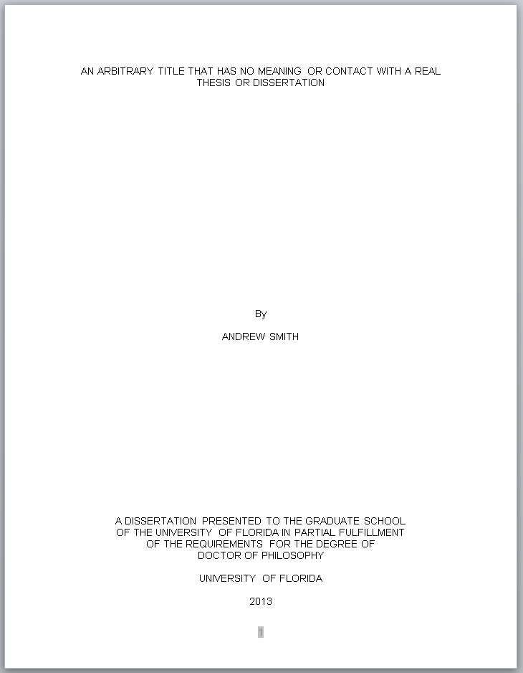

The title page should be in all capital letters. Title and statements should be typed single-spaced. Bottom and top margins should be only 1 inch.
APPENDIX B

COPYRIGHT PAGE SAMPLE
A copyright page is required for all ETDs. The author of the thesis or dissertation is automatically the copyright holder. Candidates who plan to register copyright must include a copyright page in their dissertation. The copyright page is the first page after the title page; it is counted as page 2 but it is not listed in the table of contents.

Same name as on the Title Page, only typed in upper and lower case here

APPENDIX C

TABLE OF CONTENTS SAMPLES

Sample Table of Contents for Numbered Chapters
These samples show capitalization, spacing, and format. Use the appropriate sample, depending on the organization of your manuscript.
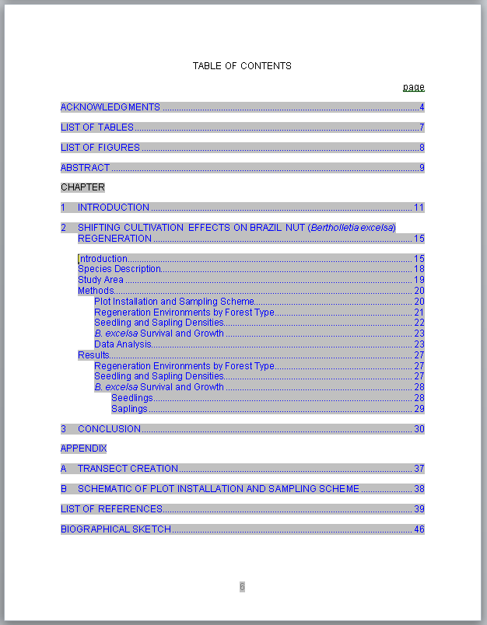

Sample Table of Contents for Numbered Chapters and Subdivisions
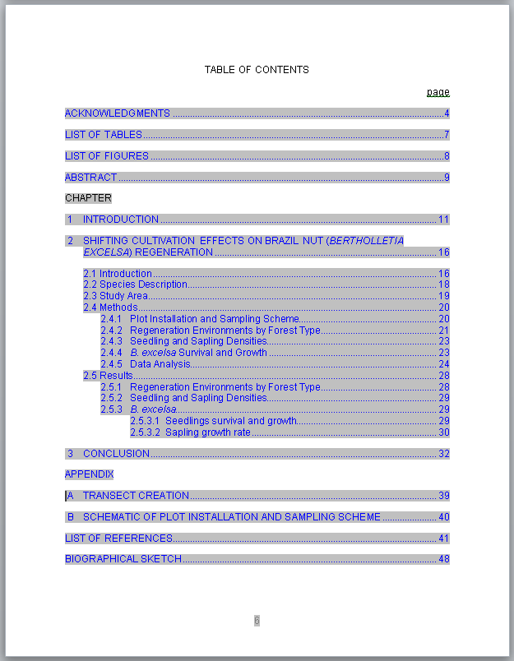

Sample Table of Contents for Theses and Dissertations without Chapter Numbers
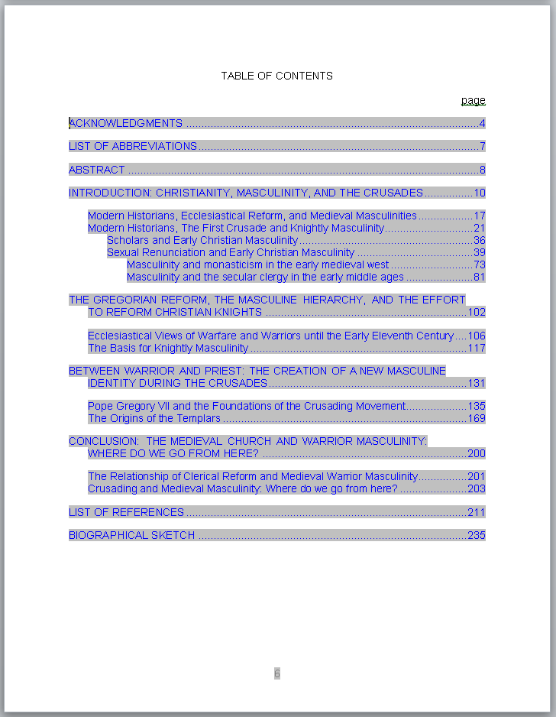

Note: Do not use this format if you refer to your chapters by number.

Sample Table of Contents for Creative Writing
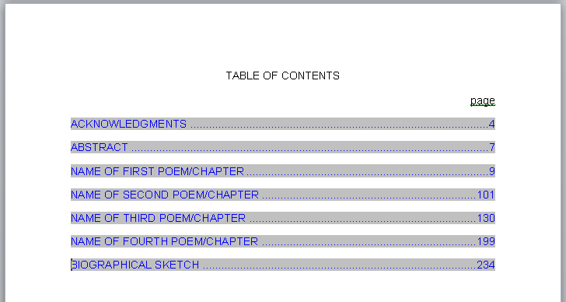
Note: Should further subdivisions be desired, follow the formatting guidelines set for all headings and subheadings as shown in this guide for theses and dissertations.

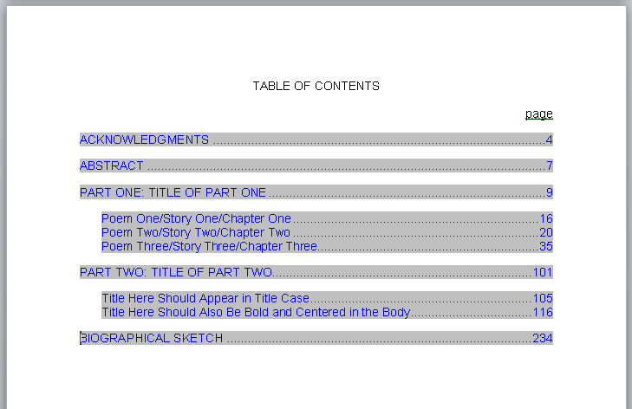

NOTE: This page is an example of how to request permission to use copyrighted material and is not to be included in the Thesis or Dissertation. If you use material from another author you must submit this completed form to the Graduate Editorial Office prior to receiving Final Clearance.

Permission to Reproduce Copyrighted Material
Any candidate who intends to quote or reproduce material beyond the limits of "fair use" from a copyrighted source must have written permission from the copyright holder. A copy of this written approval must be submitted to the Graduate School Editorial Office no later than the final submission date of the term the candidate graduates.

The form below is intended to aid the candidate in fulfilling his or her responsibility.
_______________________________________________________________________.

PERMISSION TO QUOTE/REPRODUCE COPYRIGHTED MATERIAL

I (We),_______________________________________, owners(s) of the copyright of the work known as _______________________________________________________
________________________________________________________________________
________________________________________________________________________

hereby authorize _________________________________ to use the following material as part of his/her thesis/dissertation to be submitted to the University of Florida.

Page Inclusive Line Numbers Passages to be Quoted/Reproduced

The following should be added for doctoral students:

I (We) further extend this authorization to ProQuest Information and Learning Company (PQIL), Ann Arbor, Michigan, for the purposes of reproducing and distributing microfilmed copies of the dissertation.

_______________________________________
Signature of Copyright Holder

_______________________________________
Date

LIST OF REFERENCES
Reference styles will vary widely from discipline to discipline. The only constant is that all references should be single-spaced, with a space between each reference. No Reference should split across pages. This is an example of 018 Reference Hanging.
Beland, J. (2004). NCAA board approves athletics reform. Academe, 90(5), 13.
Benson, K. F. (2000). Constructing academic inadequacy: African American athletes’ stories of schooling. Journal of Higher Education, 71, 223-246.
Brewer D. J., Eide, E. R., & Ehrenberg, R. G. (1999). Does it pay to attend an elite private college? Cross-cohort evidence on the effects of college type on earnings. The Journal of Human Resources, 34(1), 104-123.
Cuyjet, M. J. (1997). African American men on college campuses: Their needs and perceptions. New Directions for Student Services, 80, 5-16.
Diprete, T. A., & Buchman, C. (2006). Gender-specific trends in the value of education and the emerging gender gap in college completion. Demography, 43(1), 1-24.
Edwards, H. (2000). Crisis in Black athletes on the eve of the 21st century. Society 37(3), 9.
Fountain, J. J., & Finley, P. S. (2009). Academic majors of upperclassmen football players in the Atlantic Coast Conference: An analysis of academic clustering comparing White and minority players. Journal of Issues in Intercollegiate Athletics, 2, 1-13.
Gill, E., & Goff, A. (2008). The role of academic advisors in National Collegiate Athletic Association academic reform. [Monograph]. National Academic Advising Association, 18, 37-41.
Harrison, C. K. (2002). Scholar or baller in American higher education: A visual elicitation and qualitative assessment of the student-athlete’s mindset. NASPA Journal, 8(1), 66-81.
Jameson, M., Diehl, R., & Danso, H. (2007). Stereotype threat impacts college athletes’ academic performance. Current Research in Social Psychology 12(5), 68-76.
Kuh, G. D., Cruce, T. M., Shoup, R., Kinzie, J., & Gonyea, R. M. (2008). Unmasking the effects of student engagement on first-year college grades and persistence. The Journal of Higher Education, 79(5), 540-563.
Lotkowski, V. A., Robbins, S. B., & Noeth, R. J. (2004). The role of academic and non-academic factors in improving college retention. Iowa City, IA: ACT Policy Report.
Martin, B. E. & Harris III, F. (2006). Examining productive conceptions of masculinities: Lessons learned from academically driven African American male student athletes. Journal of Men’s Studies, 14(3), 359-378.
National Center for Educational Statistics. (1996). See who can play? An examination of NCAA’s Proposition 16. Retrieved June 10, 2010 from http://nces.ed.gov/pubs95/95763.pdf
On the other hand, some people prefer the block style for their reference list. In that case you shold use 017 Reference Block Style
Owens, S. J. (2011, January 10). College season tainted by scandal. Orlando Sentinel, C1, C6.
Pascarella, E. T., Edison, M., Hagedorn, L. S. , Nora, A., & Terenzini, P. (1996). Influences of students’ internal locus of attribution for academic success in the first year of college. Research in Higher Education, 37, 731-753.
Rishe, P. J. (2003). A reexamination of how athletic success impacts graduation rates: Comparing student-athletes to all other undergraduates. American Journal of Economics and Sociology 62(2), 407-427.
Sedlacek, W. E. (1999). Black students on White campuses: 20 years of research. Journal of College Student Development, 40(5), 538-549.
Tucker, I. B. (2004). A reexamination of the effect of big-time football and basketball success on graduation rates and alumni giving rates. Economics of Education Review, 23(6), 655-661.
Valentine, J. J., & Taub, D. J. (1999). Responding to the developmental needs of student athletes. Journal of College Counseling, 3, 164-178.
Waller, J. M. (2003). A necessary evil: Proposition 16 and its impact on academics and athletics in the NCAA. DePaul Journal of Sports Law & Contemporary Problems, 1(2), 189-207.

BIOGRAPHICAL SKETCH
A biographical sketch is required of all candidates. The biographical sketch should be in narrative form. Third person, past tense, it typically includes the educational background of the candidate. The author should have replaced this paragraph with their own.

* This chapter is reprinted with permission from Adelman, C. (1983). The major seventh: Standards as a leading tone in higher education. New Directions for Higher Education, 43, 39-54
Footnotes must restart at 1 at the beginning of each chapter. The exception is the un-numbered footnote that credits the publishing journal of a previously published chapter.
In most instances you need only to change the numbering to restart each section and apply changes to the whole document. Then, end each chapter with a section break – next page.
* This chapter is reprinted with permission from Adelman, C. (1983). The major seventh: Standards as a leading tone in higher education. New Directions for Higher Education, 43, 39-54
Footnotes must restart at 1 at the beginning of each chapter. The exception is the un-numbered footnote that credits the publishing journal of a previously published chapter.
In most instances you need only to change the numbering to restart each section and apply changes to the whole document. Then, end each chapter with a section break – next page.
* This chapter is reprinted with permission from Adelman, C. (1983). The major seventh: Standards as a leading tone in higher education. New Directions for Higher Education, 43, 39-54
Footnotes must restart at 1 at the beginning of each chapter. The exception is the un-numbered footnote that credits the publishing journal of a previously published chapter.
In most instances you need only to change the numbering to restart each section and apply changes to the whole document. Then, end each chapter with a section break – next page.

